US Budget Process:

The annual appropriations process generally involves three major milestones: President’s budget request, congressional deliberation and enactment of appropriations, and Administration development of a USACE work plan. The process begins with the release of the President’s budget request, typically in early February (i.e., roughly eight months before the start of the fiscal year addressed by the request), although it is sometimes delayed. Congress may consider the President’s budget request, stakeholder interests, and other factors when creating an annual Energy and Water Development appropriations bill that includes USACE civil works activities. The length of the congressional appropriations process varies from year to year. Following enactment of the Energy and Water Development bill, the Administration develops a USACE work plan, which identifies the amount of additional funding provided to specific studies and projects.

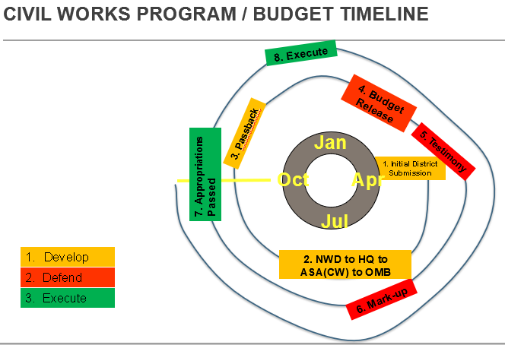
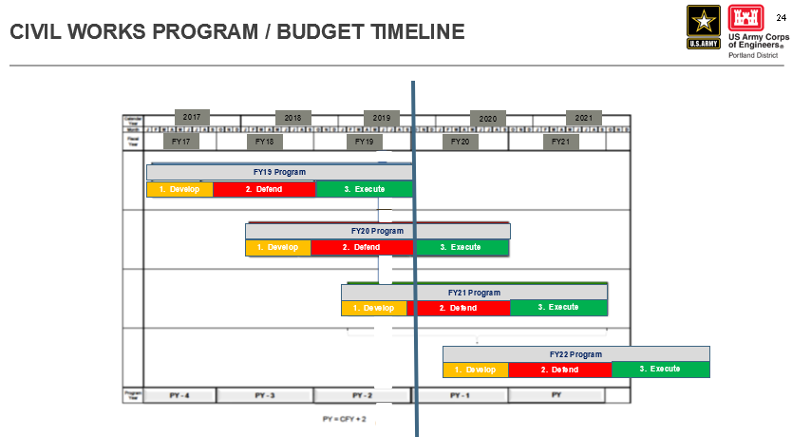

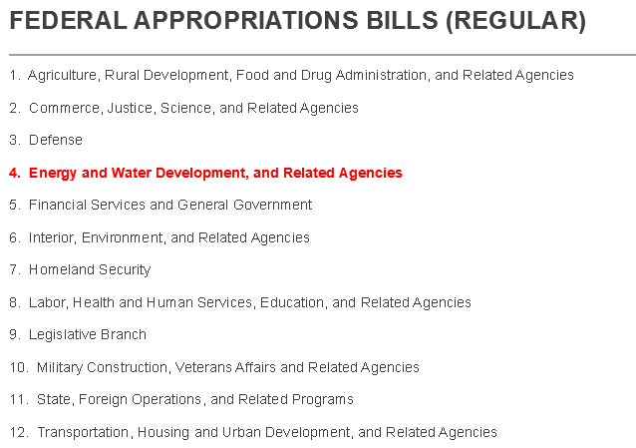

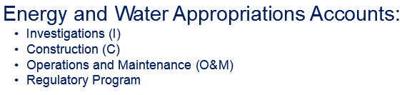
CRFM = Construction General

